**IT2120 - Probability and Statistics**

**Lab Sheet 04**

**IT24102799**

**Siriwardhana S.A.D.N**

Exercise

1. Import the dataset (’Exercise.txt’) into R and store it in a data frame called” branch data”.

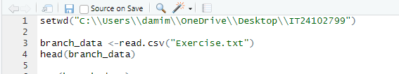

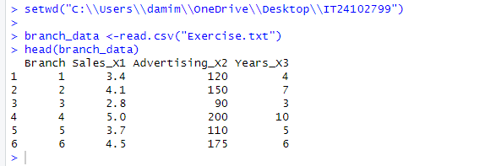

2. Identify the variable type and scale of measurement for each variable.



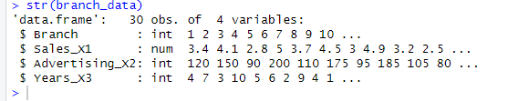

3. Obtain boxplot for sales and interpret the shape of the sales distribution.

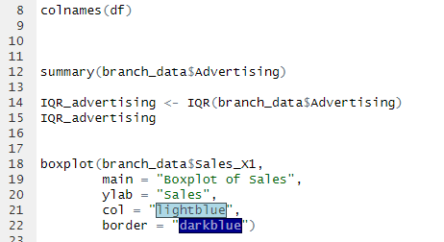

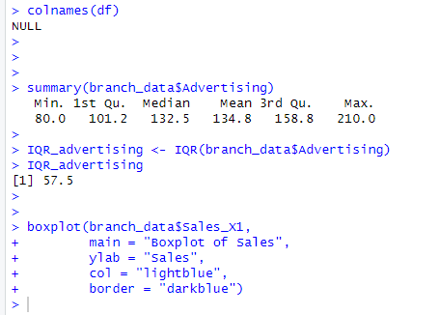

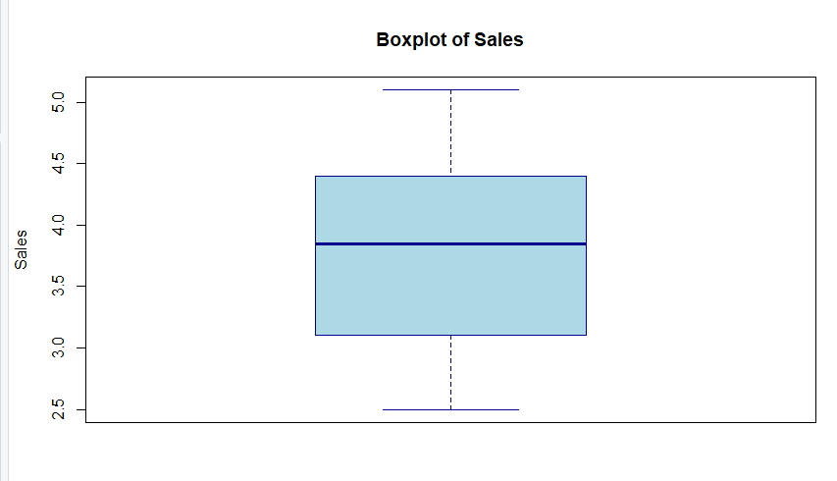

4. Calculate the five number summary and IQR for advertising variable.

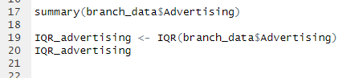

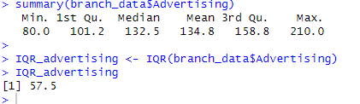

5. Write an R function to find the outliers in a numeric vector and check for outliers in years variables.

